Name: Period:

EXIT TICKET

Directions: Write the name of the notes below.

1. i 2. p 3. o

Compose a 3- measure rhythm. Choose a Clef (bass or treble), Time Signature (3/4, 4/4, 2/4, 6/8, or 12/8) use at least 3 different notes from our G major Scale.

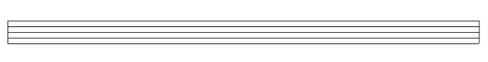

Write a little bit about your composition and explain why it makes sense using the criteria above.