Music Summative
1. Label the following time signatures as compound or simple meter and explain how you know this. (8)
Meter | Simple or Compound | How do you know?
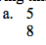
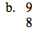
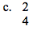
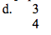

2. Divide the following example into measures by placing bar lines in the appropriate places. (6 points)
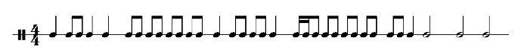
3. How many eighth notes equal a half note? (1 point)
a. 6 b. 10 c. 4 d. 8
How do you know this? (1 point)

4. Complete the measures by the addition of rests, so that the rhythm of each measure corresponds to the given time signature. To observe the rules of rhythmic grouping, place each rest at an appropriate spot. (4 points)
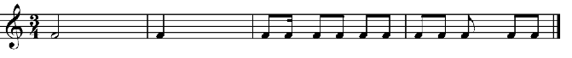

5. Which of the following terms best indicates the tempo of this musical excerpt (1 point)
a. Presto b. Largo c. Andante d. Adagio e. Allegro
6. Name the Major Key Name based on the key signature. (8 points)
Key Signature | Name | How do you know?
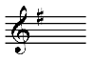
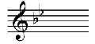
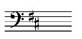
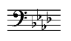

7. Label each of the following intervals based on size and type (M –Major, m-minor, 1,2,3,4,5,6,7) (9 points)
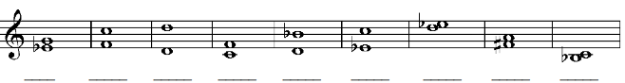

Listening Portion
8. Listen to the following musical excerpts does this sound Major, Minor, or None of the Above. How do you know? (6 points)
Excerpt | Major, Minor, None of the above | How do you know?
1.
2.
3.

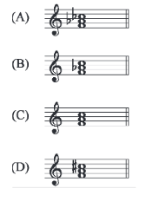
9. Which of the following was played? (1 point)

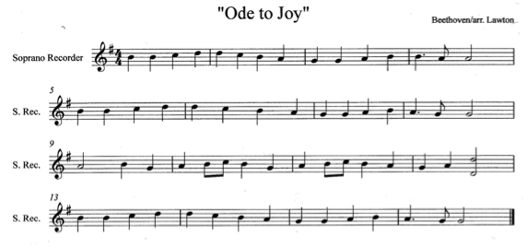
10. Look at the following song for recorder. The music is printed correctly, but the performance will contain 3 errors. Answer the questions below based on these mistakes.

1. The mistake in measure 3 was due to pitch or rhythm? Explain what was wrong? (2 points)

2. The mistake in measure 8 was due to pitch or rhythm? Explain what was wrong? (2 points)

11. Listen to the following musical excerpt what instruments do you hear? (1 point)
a. flute, piano b. clarinet, harp c. flute, harp d. clarinet, piano
12. Listen to the following musical excerpt what ensemble do you hear? (2 points)
a. Band b. Orchestra c. Choir d. Jazz Band
How do you know this is true?

13. What instrument starts the introduction of this piece of music? (1 point)
a. Trumpet b. Clarinet c. Drums d. Flue

14. Is the texture of this song thick or thin? How did you know? (2 points)

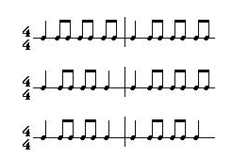
15. Circle the rhythm I perform (1 point)

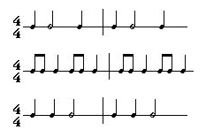
16. Circle the rhythm I perform (1 point)

17. Listen to me perform the melody and circle the right answer (1 point)
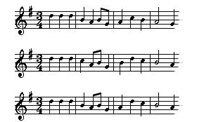
18. Listen to me perform the melody and circle the right answer (1 point)
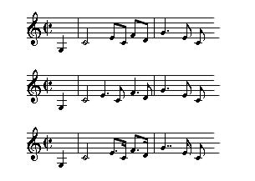

19. Mr. Loughran is going to play a song on recorder starting on G he will play this 5 times. Write down the song he is playing below. (7 points)
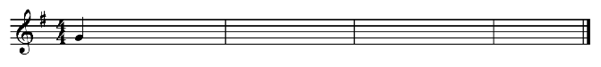
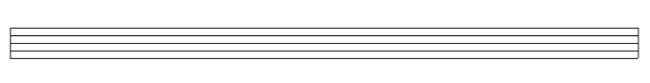
20. Compose a 2-measure song. Choose Clef, Time Signature, and at least 4 different notes. (10 points)

Write a little bit about your composition and explain why it makes sense using the criteria above.

21. Listen to the following song and answer the following questions (4 points)

Dynamics | Tempo | Instruments

Describe the Aesthetic of the piece of music using the table above.

