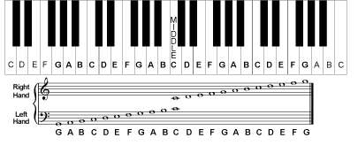
Music Theory Quiz:
Symbols, Note Values, Time Signatures

A. Musical Symbols
1. Why do pitches go up when we move to the right of the piano?

2. When do pitches move down when we move to the left of the piano?

3. 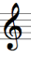This is a treble clef also known as ___________
a. F Clef
b. G Clef
c. Alto Clef
BONUS: Why is it called the G Clef, what was it’s purpose?

4. F Clef is another name for ___________
a. Treble Clef
b. Bass Clef
c. Alto Clef
BONUS: Why was this called the F clef? What was it’s purpose?

5. Smallest interval in western music
a. Whole Step
b. Flat
c. Half Step

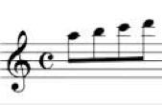
6. The composer below is relying on ledger lines to begin his piece of music? What is the purpose of ledger lines? Why are these useful?

7. Notes that are raised are considered to be ___________
a. Sharp
b. Flat
c. Natural
8. Notes that are lowered are considered to be ___________
a. Sharp
b. Flat
c. Natural
B. Half and Whole Steps
1. Write down the name of each note below and then label the intervals Look at the intervals below put HALF or WHOLE
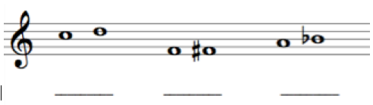
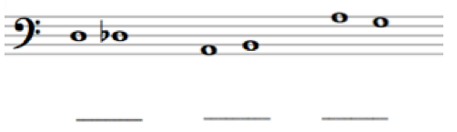

2. Listen to the following examples. Put HALF or WHOLE.
1.___________  How do you know? | 2._____________  How do you know? | 3._____________  How do you know? | 4.______________  How do you know?

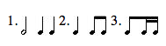
C. Note Values and Time Signatures
1. Which of the following equals a half note and why?

2. This note below not equal a dotted half note.
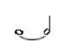
a. Explain Why?

b. Draw 2 notes tied together that would equal a dotted half note.

3. Fill in the table at the following Time Signatures and answer the questions below.
Time Signature | Simple or Compound | How many beats? | What gets the beat?
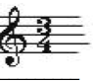
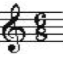
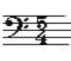

Time Signature | Music
 | 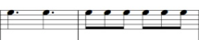
 | 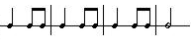
4. Decide what time signature each rhythm is below.

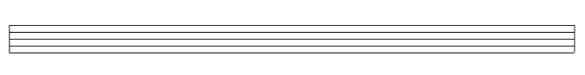
5. Compose a THREE measure rhythm that must include the following:
a. Clef (1 point)
b. Time Signature (1 point)
c. Three Measures (3 points)
d. At least one dot or tied note (1 note)

Write a little bit about your composition and explain why it makes sense using the criteria above.

6. Listening
Dynamics | Tempo | Instruments

Describe the Aesthetic of the piece of music using the table above.

